**Program: -1**

**Objective**: Write a Program in Java to print Hello.

**Code:**

public class Main {  
 public static void main(String[] args) {  
 System.*out*.println("Hello world!");  
 }  
}

**Output:**

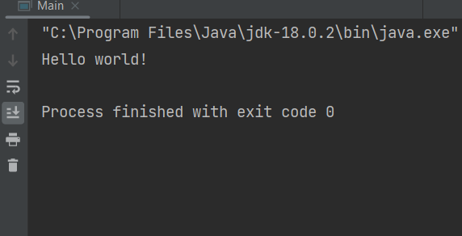

**Program: -2**

**Objective**: Write a program in java to understand the difference between print() and println().

**Code:**

public class Main {  
 public static void main(String[] args) {  
 int num1 = 10;  
 int num2 = 20;  
  
 // Using print() method  
 System.*out*.print("The sum of ");  
 System.*out*.print(num1);  
 System.*out*.print(" and ");  
 System.*out*.print(num2);  
 System.*out*.print(" is: ");  
 System.*out*.print(num1 + num2);  
  
 // Using println() method  
 System.*out*.println("\nThe sum of " + num1 + " and " + num2 + " is: " + (num1 + num2));  
  
 System.*out*.println("This is println()");  
 System.*out*.print("This is print()");  
 System.*out*.print("\n");  
 System.*out*.println("Now we are using println()");  
 }  
}

**Output:**

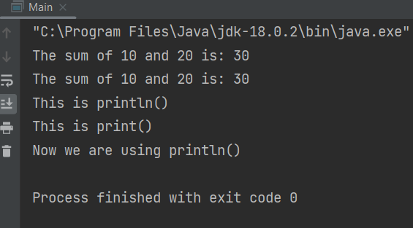

**Program: -3**

**Objective**: Write a program in Java with two classes create a object of first class and call into another class (having main method).

**Code:**

// FirstClass.java  
class FirstClass {  
 public void displayMessage() {  
 System.*out*.println("Hello from FirstClass!");  
 }  
}  
  
public class Main {  
 public static void main(String[] args) {  
 FirstClass obj = new FirstClass(); // Creating object of FirstClass  
 obj.displayMessage(); // Calling method of FirstClass  
 }  
}

**Output:**

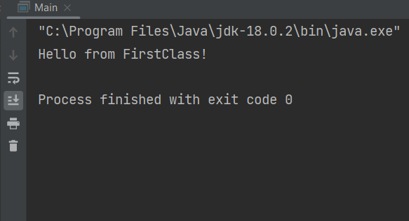

**Program: -4**

**Objective**: Write a program in Java to product of two numbers.

**Code:**

public class Main {  
 public static void main(String[] args) {  
 int a = 5;  
 int b = 8;  
 System.*out*.println("The product of two number: "+(a*b));  
 }  
}

**Output:**

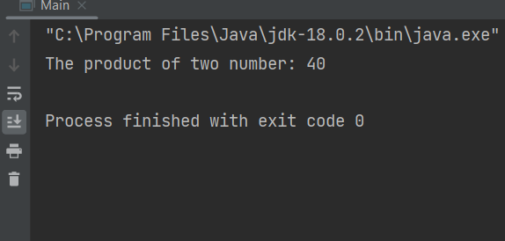

**Program: -5**

**Objective**: Write a program in Java to product of two numbers (Input by the

user).

**Code:**

import java.util.Scanner;  
  
public class Main {  
 public static void main(String[] args) {  
 Scanner scanner = new Scanner(System.*in*);  
  
 // Prompt the user to enter the first number  
 System.*out*.print("Enter the first number: ");  
 double num1 = scanner.nextDouble();  
  
 // Prompt the user to enter the second number  
 System.*out*.print("Enter the second number: ");  
 double num2 = scanner.nextDouble();  
  
 // Calculate the product of the two numbers  
 double product = num1 * num2;  
  
 // Display the result  
 System.*out*.println("The product of " + num1 + " and " + num2 + " is: " + product);  
  
 // Close the scanner  
 scanner.close();  
  
 }  
}

**Output:-**

